Sprint 3 Plan

Product Name : UpToDate

Team Name: UpToDaters

Release Name : UpToDate

Release Date : 3/19/18

Revision Number : 2

Revision Date : 3/4/18

Goal: Connect frontend template engine to backend sql database

Task Listing

* User Story 1: As a user, I want to be able to see the articles for each category on the website. (8 points)
  + Task 1: Connect the frontend to the backend (3 hours)
  + Task 2: Create a layout for articles to be displayed (3 hours)
* User Story 2: As a developer, I want to be able to store the trending videos link in a database (10 points)
  + Task 1:Implement Youtube’s api for Django (5 hours)
  + Task 2:Create tables in SQLite for user topics and create table for all the video links (2 hours)
  + Task 3:Create a programmatic flow that iterates the user topic table and updates the videoTable (1 hour)
  + Task 4:Extract data from the database(2 hours)

Team Roles

* Team Member Manav Sharma: Product Owner
* Team Member Tariq Anees: Scrum Master
* Team Member Andrew Boyadjiev: Developer
* Team Member Arthur Kung: Developer
* Team Member Tommy Tran: Developer
* Team Member Vanessa Tan: Developer

Initial Task Assignment

* Team Member Manav Sharma will work on user story #2 and his task is to implement Youtube’s api for Django
* Team Member Tariq Anees will work on user story #1 and his task is to add a toggle with all user topics as options
* Team Member Andrew Boyadjiev will work on user story #1 and his task is to create a single layout that articles can be displayed on
* Team Member Arthur Kung will work on user story #2 and his task is to Create tables in SQLite for user topics and create table for all the video links
* Team Member Tommy Tran will work on user story #2 and his task is to extract data from the database.
* Team Member Vanessa Tan will work on user story #2 and her task is to Create a programmatic flow that iterates the user topic table and updates the videoTable.

Burn Up Chart

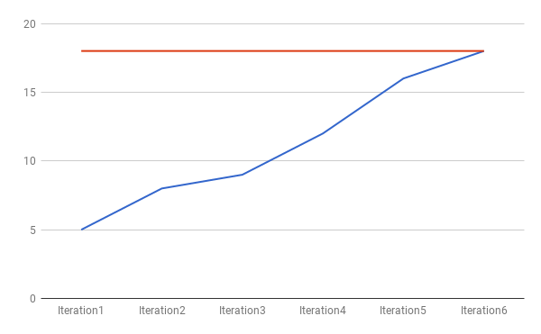

Scrum Times

* Monday at 11:30 am (TA visit)
* Wednesday at 9:00 am
* Friday at 9:00 am

Scrum Board

